Problem Statement 1: Write a Java program to display the content of a file in HDFS on screen.

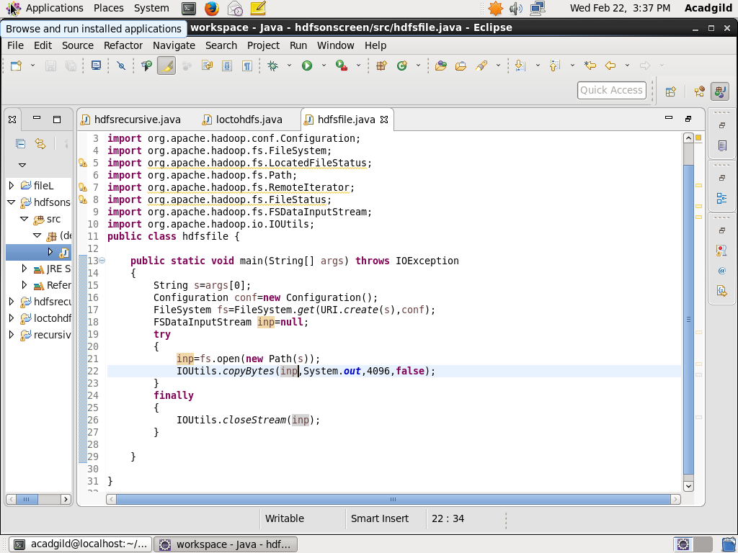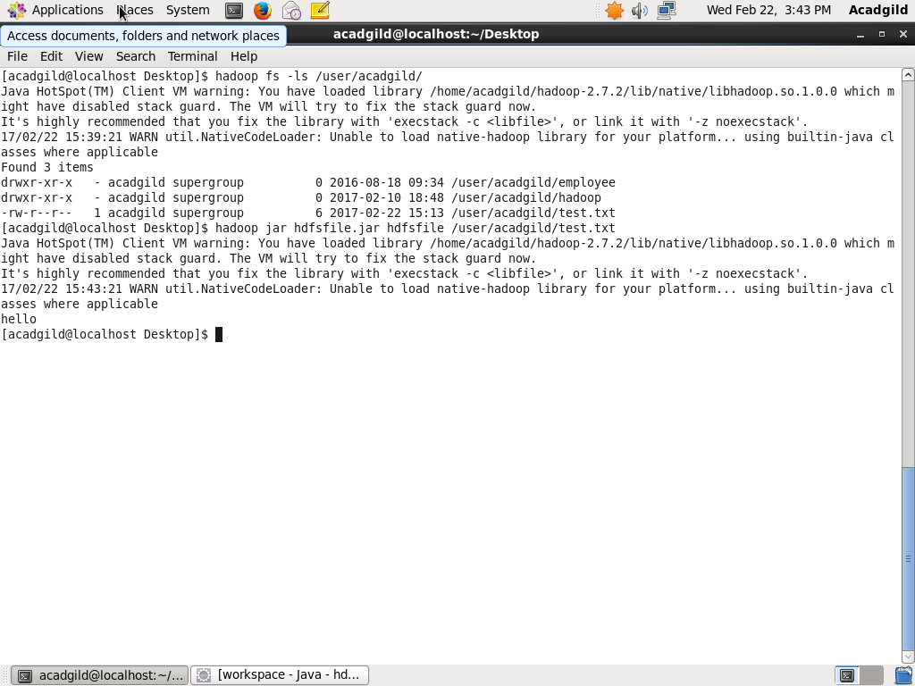

Problem Statement 2: Write a Java program to copy a file from local filesystem to HDFS.

